Intuition
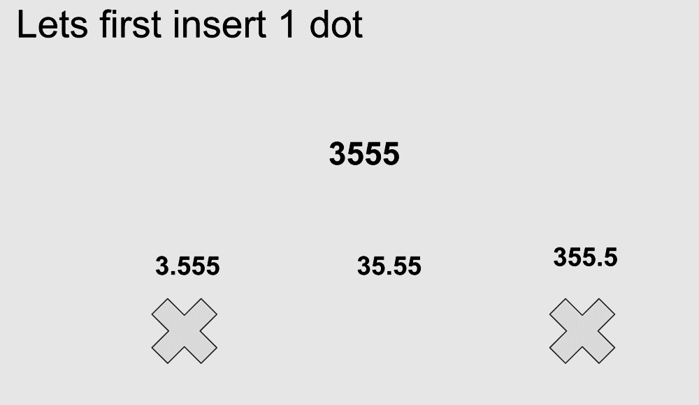
Let’s take a very simple scenario where we insert just one dot.
Quick Observation: The length of the string can be 1, 2 or 3 as the range is 0,255.
Once the function has inserted the dot, it will verify if the string is valid or not, in the above example 355 is not valid[i.e., 355.5], so we can discard it.
However we have one more invalid case i.e. 3.555 as string 555 is not valid. The approach we can use here is, though we are inserting one dot, we will make it to insert 2 dots so that the same function will check the validity of the second part and remove the last dot from ans.
The same approach goes for 3 dots, at each step add a dot --> generate valid answers and pass it down again.
